**Electric battery**

A **battery** is a device consisting of one or more electrochemical cells with external connections for powering electrical devices such as flashlights, mobile phones, and electric cars.

Or

Batteries are a collection of one or more cells whose chemical reactions create electrons in a circuit

Or

A Battery is a chemical device that store electrical energy in the form of chemicals and by means of electrochemical reaction, it converts the stored chemical energy into direct current electric energy.

All batteries are made up of three basic components: an **anode (the '-' side),** **a cathode (the '+' side)**, and some kind of **electrolyte** (a substance that chemically reacts with the anode and

cathode). When a battery is supplying electric power, its positive terminal is the cathode and its negative terminal is the anode. The terminal marked negative is the source of electrons that will flow through an external electric circuit to the positive terminal. When a battery is connected to an external electric load, a redox reaction converts high-energy reactants to lower-energy products, and the free-energy difference is delivered to the external circuit as electrical energy.

Historically the term "battery" specifically referred to a device composed of multiple cells; however, the usage has evolved to include devices composed of a single cell. Alessandro Volta, an Italian Physicist, invented the first battery in 1800.

The **2019 Nobel Prize** in Chemistry has been awarded to three scientists **John B. Goodenough, M. Stanley Whittingham and Akira Yoshino** for the development of **lithium-ion batteries**.

**Battery types**

Batteries can be broadly divided into two major types.

1. Primary Cell / Primary battery
2. Secondary Cell / Secondary battery
3. **Primary Cell / Primary battery**

Primary (single-use or "disposable") batteries are **used once** and discarded, as the electrode materials are irreversibly changed during discharge; a common example is the **alkaline battery** used for flash

Usually, primary batteries are inexpensive, light weight, small and very convenient to use with relatively no or less maintenance. Majority of the primary batteries that are used in domestic applications are single cell type and usually come in cylindrical configuration (although, it is very easy to produce them in different shapes and sizes).

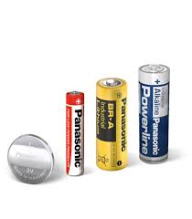

**2. Secondary Cell / Secondary battery**

Secondary (rechargeable) batteries can be discharged and recharged multiple times using an applied electric current; the original composition of the electrodes can be restored by reverse current. Examples include the lead-acid batteries used in vehicles and lithium-ion batteries used for portable electronics such as laptops and mobile phones.

Energy Density of secondary batteries are relatively lower than that of primary batteries but have other good characteristics like high power density, flat discharge curves, high discharge rate, low temperature performance.

Two of the oldest batteries are in fact secondary batteries called the **Lead – Acid Batteries**, which were developed in late 1850’s and **Nickel – Cadmium Batteries**, which were developed in early 1900’s. Until recent times, there are only two types of secondary batteries.

The first and the most commonly used rechargeable batteries are called Lead – Acid Batteries. They are based on the Lead – Lead Dioxide (Pb – PbO2) electrochemical couple. The electrolyte used in these types of batteries is the very common Sulfuric Acid.

The second type of the rechargeable batteries are called Nickel – Cadmium Batteries. They are based on Nickel Oxyhydroxide (Nickel Oxide) as the positive electrode and Cadmium metal based negative electrode. Coming to the electrolyte, an alkaline solution of Potassium Hydroxide is used.

In the recent decades, two new types of rechargeable batteries have emerged. They are the **Nickel – Metal Hydride Battery** and **the Lithium – Ion Battery**. Of these two, the lithium – ion battery came out to be a game changer and became commercially superior with its high specific energy and energy density figures (150 Wh / kg and 400 Wh / L).

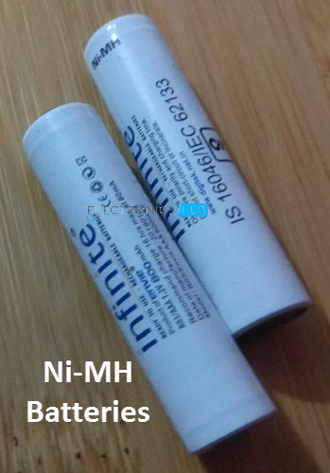

There are some other types of Secondary Batteries but

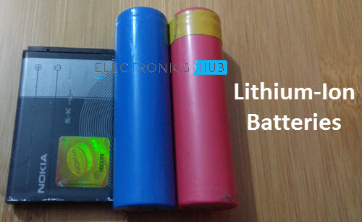

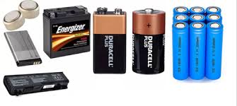

Batteries come in many shapes and sizes, from miniature cells used to power hearing aids and wristwatches to small, thin cells used in smartphones, to large lead acid batteries or lithium-ion batteries in vehicles, and at the largest extreme, huge battery banks the size of rooms that provide standby or emergency power for telephone exchanges and computer data centers.

The four major types are:

* Lead – Acid Batteries
* Nickel – Cadmium Batteries
* Nickel – Metal Hydride Batteries
* Lithium – Ion Batteries
* Based on the application of the battery, they can be classified again.

They are:

* **Household Batteries**

These are the types of batteries which are more likely to be known to the common man. They find uses in a wide range of household appliances (such as torches, clocks, and cameras). These batteries can be further classified into two subcategories:

* + Rechargeable batteries   
    Examples: Cadmium batteries, Lithium-Ion
  + Non-rechargeable batteries  
    Examples: Silver oxide, Alkaline & carbon zinc

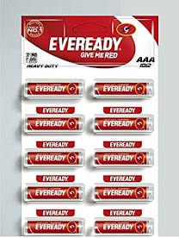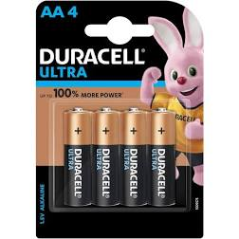

Alkaline AA Batteries Carbon Zinc AAA Battery

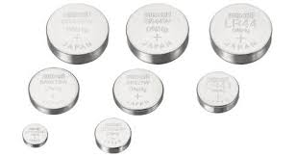

Silver oxide Battery

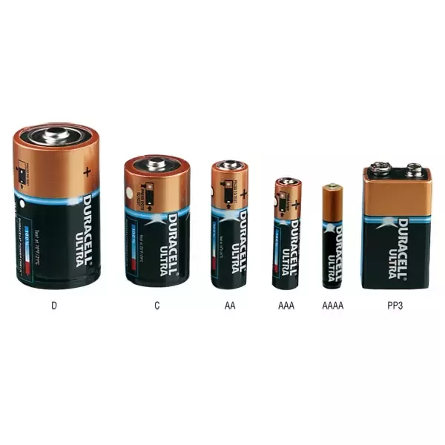

A big difference between **AA** and **AAA** batteries lies in their size. **The higher the alphabet, the smaller is the battery.** That means AAA batteries are smaller than AA batteries. ... Bulky equipment like toys and cameras need AA batteries since they are wider and longer than the AAA batteries. This is important, as battery operated devices often use only one specific size. Although you cannot fit an AA battery on an AAA slot, you may be able to find adaptors that can make an AAA battery fit on an AA slot.

AA and AAA batteries carry the same amount of voltage, as do bigger batteries, like the D type. This is because they are basically just a single cell. 9 Volt batteries utilize six cells in a series to come up with the higher voltage.

The usage of AA and AAA batteries often varies, and there are no set standards for when to use one over the other, but you are more likely to find that devices which consume a lot of power, use AA batteries. Examples of high consumption devices, are battery operated toys and small electric torches. These devices also use more than one AA cell to raise the voltage, or to increase the operating time. AAA batteries are often found on low power, or portable devices, that don’t consume too much power. Clocks and remote controllers are good examples of devices that don’t need frequent battery changes.

For rechargeable batteries, you would need a charger that is suited for your batteries, but in case you have both AA and AAA batteries, you can find chargers that can charge both types. They have a movable part that uses a spring to push the battery tightly into place. AA and AAA batteries share the same electrical characteristics, and the charger would not need to treat them differently.

**Summary:**

1. AAA batteries are smaller compared to the AA.

2. AAA batteries carry a smaller amount of material compared to the AA.

3. AAA batteries may carry a smaller amount of charge compared to the AA.

4. AAA batteries are commonly found in small, and low power devices, while AA batteries are for devices that consume more power.

* **Industrial Batteries**

These batteries are built to serve heavy-duty requirements. Some of their applications include railroad, backup power and more for big companies. Some examples are:  
Nickel Iron, Wet Nickel Cadmium (NiCd)

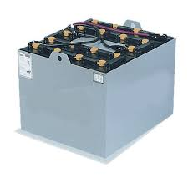

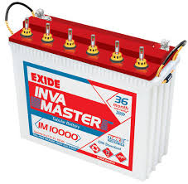

* **Vehicle Batteries**

These are more user-friendly and a less complicated version of the industrial batteries. They are specifically designed to power cars, motorcycles, boats & other vehicles. An important example of a vehicle battery is the [Lead-acid battery](https://byjus.com/chemistry/lead-acid-battery/).

